WRITING PRACTICE – PART 1-2

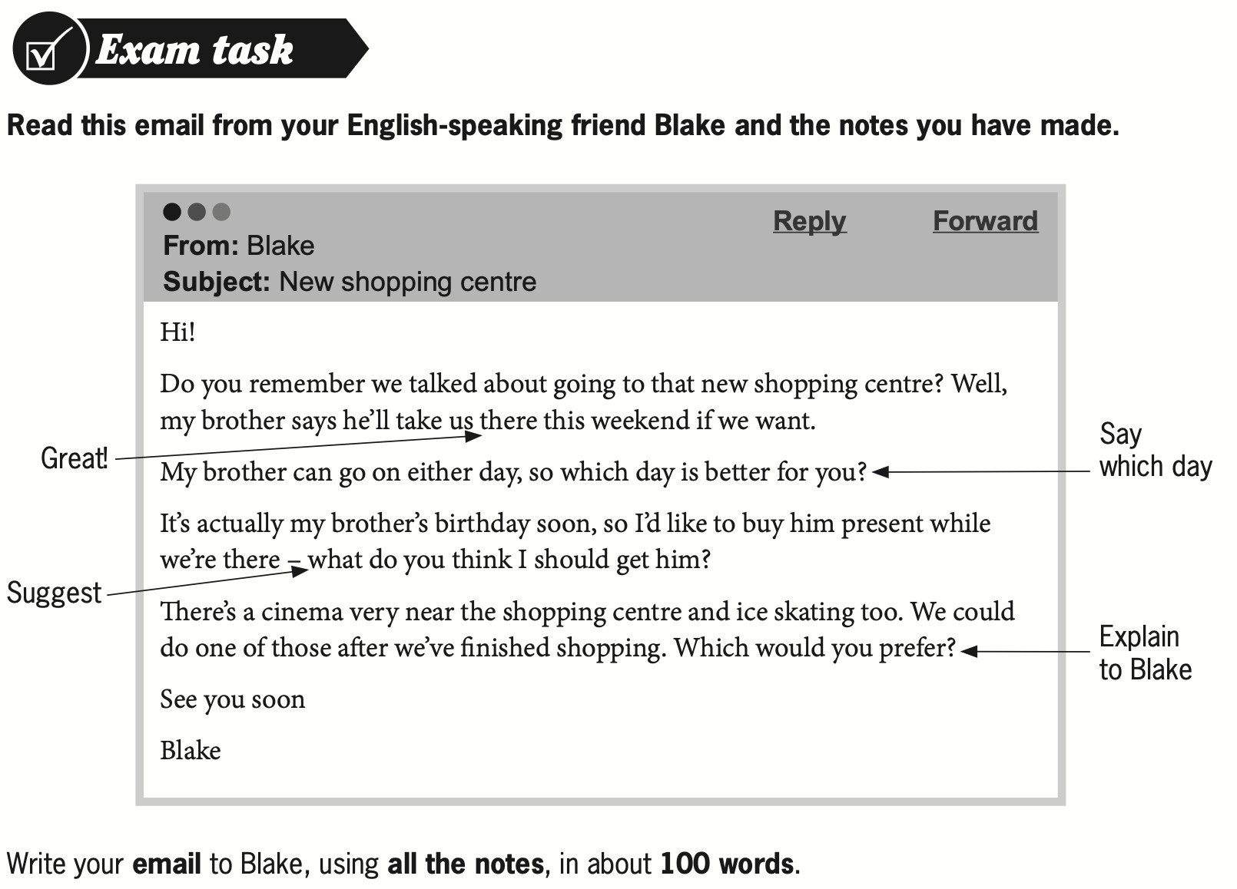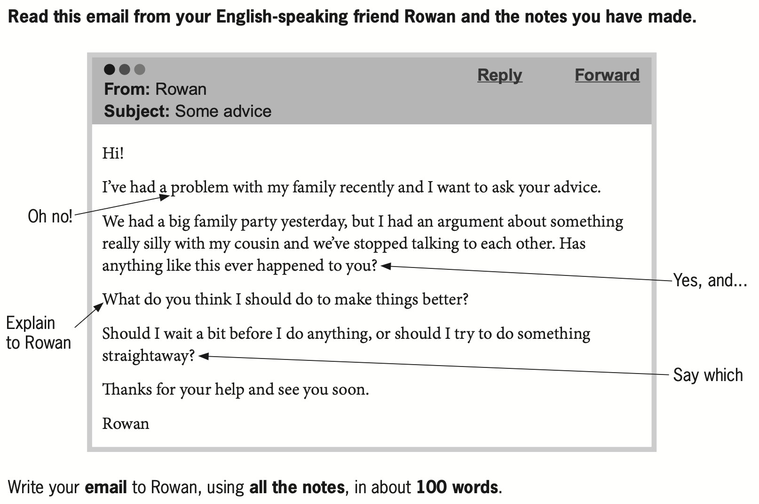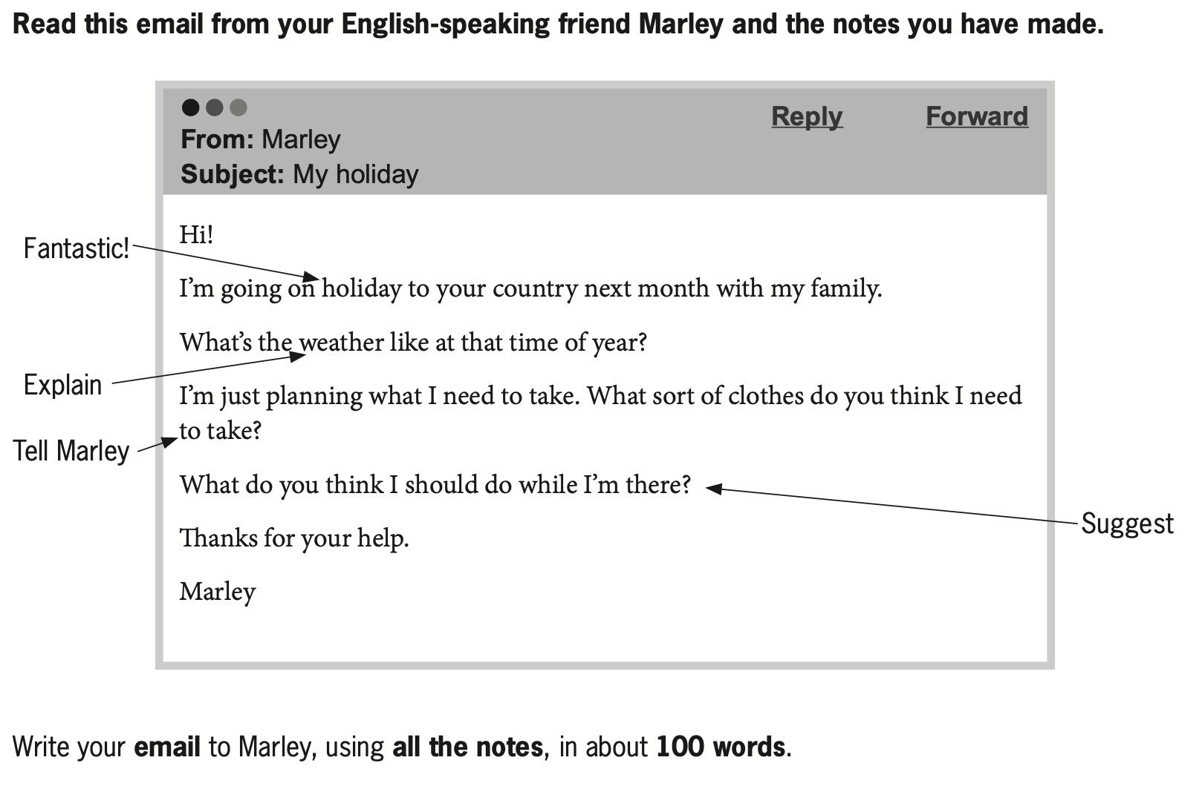

SET 1

Question 2: An article – School Holidays
You see this announcement in an English-language magazine for young people.
📰 Articles wanted – School Holidays
What do you like doing during school holidays? Why?
Some people say that school holidays should be shorter. What do you think?
✏️ Write your article in about 100 words.

Question 3: A story – A Phone Call
Your English teacher has asked you to write a story.
Your story must begin with this sentence:
“Nori put down the phone and laughed.”
✏️ Write your story in about 100 words.

SET 2

Question 2: An article – Spending Time Outdoors
You see this announcement in an English-language magazine.
📰 Articles wanted – Spending Time Outdoors
What kinds of things do people do outdoors in their free time where you live?
Do you enjoy spending time outdoors? Why?
✏️ Write your article in about 100 words.

Question 3: A story – Shoe Shopping
Your English teacher has asked you to write a story.
Your story must begin with this sentence:
“When Molly saw the shoes in the shop window, she wanted them!”
✏️ Write your story in about 100 words.

SET 3

Question 2: An article – Challenges
You see this announcement on an English-language website.
📰 Articles wanted – Challenges
What do you think is the biggest challenge for young people today?
What can they do to help themselves with this challenge?
Do you think it’s good for young people to have challenges in their lives?
✏️ Write your article in 100 words in an appropriate style.

Question 3: A story – The School Noticeboard
Your English teacher has asked you to write a story.
Your story must begin with this sentence:
“Ben saw the advert and immediately sent his friend a message.”
✏️ Write your story in about 100 words.

